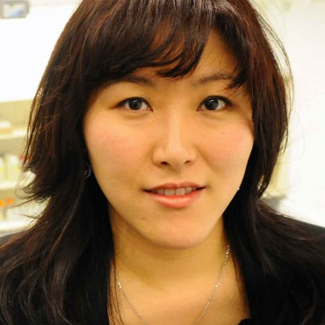
We are pleased to announce that the recipient of the inaugural award is Prof. Ah-Hyung Alissa Park, the Lenfest Earth Institute Professor of Climate Change in the Departments of Earth and Environmental Engineering & Chemical Engineering and the Director of the Lenfest Center for Sustainable Energy in the Earth Institute at Columbia University.

Prof. Ah-Hyung Alissa Park,
Departments of Earth and Environmental Engineering & Chemical Engineering, Columbia University.

Prof. Park has made significant research contributions on integrated Carbon Capture, Utilization and Storage (CCUS) technologies. This includes the development of Nanoparticle Organic Hybrid Materials (NOHMs) which are self-suspended hybrid nanomaterials in the absence of any solvent for CO₂ capture from flue gas and from air, innovative carbon mineralization chemistry with a pH swing reaction scheme and enzymatic catalyst (carbonic anhydrase) that can effectively dissolve hydrous Mg-silicate minerals and accelerate the rate of CO₂ hydration leading to carbonate, the recovery of critical elements from wastes of iron and steel plants as well as negative emission technologies including direct air capture and bioenergy with CO₂ capture and storage. She is also working on the direct carbon capture and conversion using NOHMs via electrochemical reduction of CO₂ to fuels.

Prof. Park has also served the ACS Energy and Fuels division in multiple leadership roles. She was the 2015 chair of ENFL technical program with 28 symposia and 96 sessions organized across two national meetings including the initiation of an ENFL Plenary Session. She served as the ENFL Division Chair in 2018. The division efforts under her leadership led to a significant growth in new members and extension of scientific scope of the division. Prof. Park has received a number of professional awards and honors including U.S. C3E Research Award (2018), PSRI Lectureship Award at AIChE (2018), ACS Energy and Fuels Division’s Emerging Researcher Award (2018), ACS WCC Rising Star Award (2017), and NSF CAREER Award (2009). Prof. Park is a Fellow of the American Chemical Society (ACS) and the American Institute of Chemical Engineers (AIChE). She led a number of global and national discussions on CCUS including the Mission Innovation Workshop on Carbon Capture, Utilization and Storage in 2017 and the National Petroleum Council CCUS Report in 2019. A Mid-Career Award Symposium in Honor of Prof. Park was held as part of the ENFL Division Program at ACS Fall 2022 meeting in Chicago.

